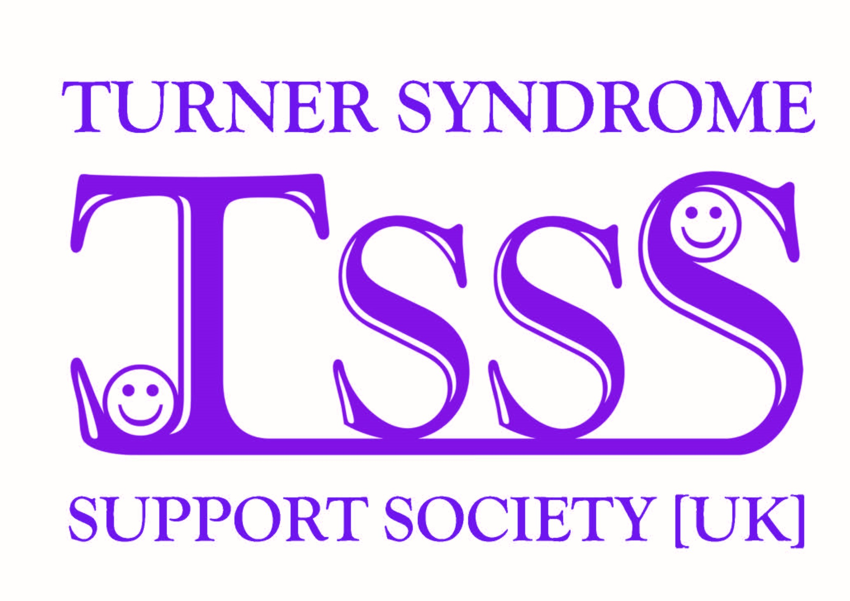
Save the Date
The Turner Syndrome Support Society [UK]
is proud to host the
10th Turner Syndrome International Conference
We are pleased to announce the conference will be held at Stirling University, Scotland, UK in the beautiful Scottish countryside, over the weekend of the 16th to the 20th of July 2020.
We are working on the logistics of the conference venue, development of a website and much more. Information will be circulated as soon we have it.
We are looking forward to welcoming National and International Delegates and Speakers from across the world, helping to bring together better knowledge and understanding of Turner Syndrome. A full specialist programme will be provided along with a social programme, where lifelong friendships flourish.
All are welcome and simultaneous programmes will run with as wide a variety as possible.
You will be assured of a warm welcome by everyone at the TSSS.
